**introduction**

This project is aimed at developing an Online Banking for customer. The system is an online application that can be accessed throughout the organization and outside as well with proper login provided.

. The database connectivity was planned using the latest “ Database connection” technology provided by Oracle. The authentication and authorization was crosschecked at all the relevant stages.

**Overview**

Internet Banking is all about knowing our customer need and provide them with the right service at the right time through right channel 24*7 day a week.

Being “electronic”, it not only provides its customers with faster and better facilities, it even reduces the manual overhead of accounts maintenance.

**ABOUT THE PROJECT**

Project is all about onine bank management system it includes deposition, transactions etc

**Purpose:**

The Online Banking suite provides a global accounting foundation that provides the all private banks with electronic banking facilities. It allows client of private banks to carry out their day to day banking transactions.

**Scope:**

The Online Banking project is widely applicable with private banks. It can even be used in industries for their personal transactions (working).

**Functional components of the project:**

Following are the functional needs of the software:-

1. Customer must have a valid user ID and password to login to the system.

2. After the valid user logs in, the system shows the present balance in that particular account number.

3. Customer can perform transactions like deposit and withdrawal from his account.

4. Proper help to be provided as and when requested by the customer.

**BANKING SYSTEM USES:**

➢Withdrawal of amount by the client.

➢Deposition of amount by the client.

➢Faster balance enquiry.

**Software Required:**

The project is implemented in ADV JAVA, hence the software’s required in the creation and execution of the project are J2EE ,NETBEANS or Eclipse .

**Technologies and Requriments**

**IDE:**

ECLIPSE NEON 3

**Front End:**

JSP, JDBC, Javascript, AJAX

**Programming Language:**

JAVA

**Back End:**

My SQL Database

**5.3 E – R DIAGRAMS:**

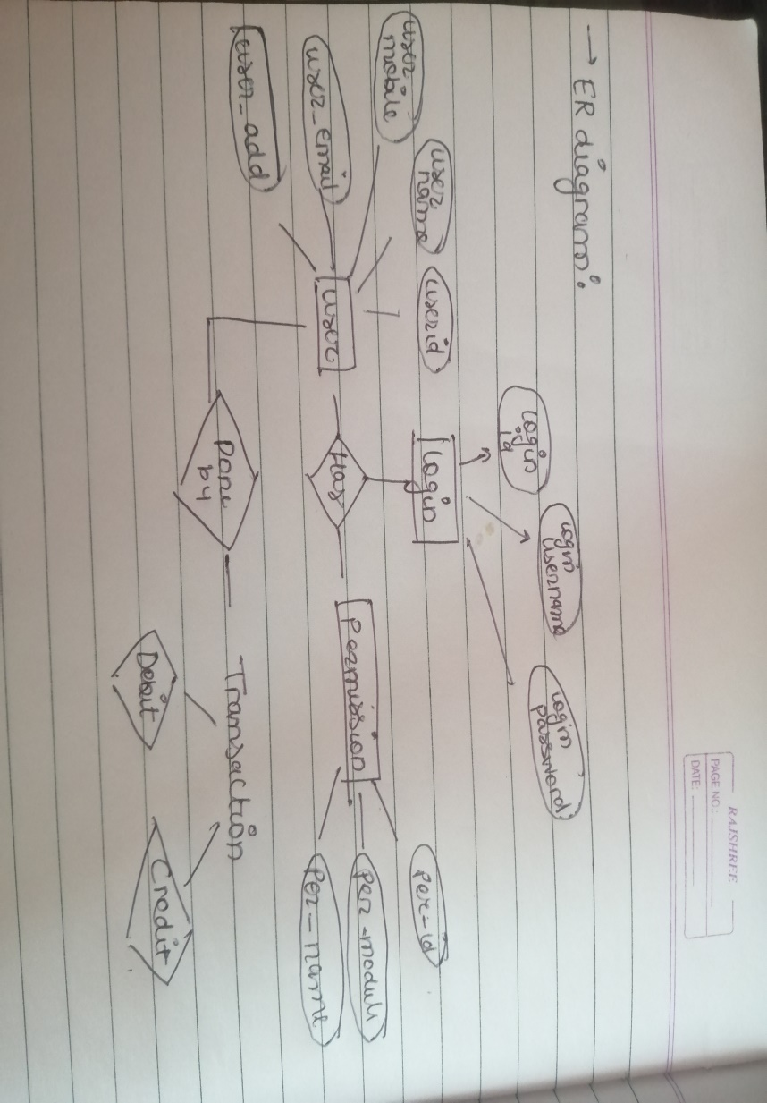

**DATA FLOW DIAGRAMS:**

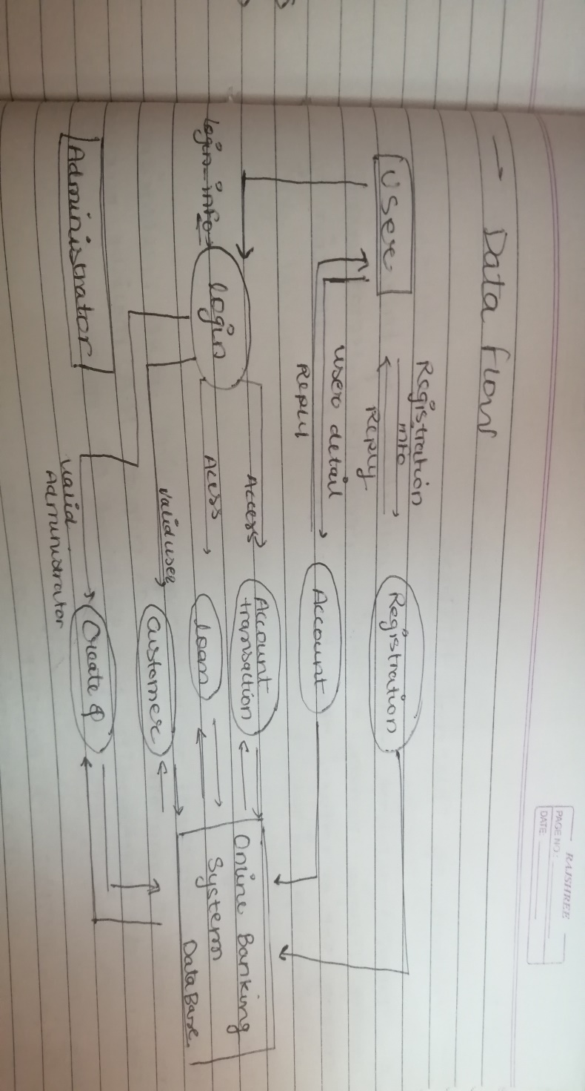

**5.5 DATABASE TABLE:**

|  |  |  |  |
| --- | --- | --- | --- |
| **Column name** | **Data type** | **Nullable** | **Primary key** |
| ACCOUNTINFO | Number | No | Yes |
| USERNAME | Varchar2 | Yes | No |
| PASSWORD | Varchar2 | Yes | No |
| AMOUNT | Varchar2 | Yes | No |
| ADDRESS | Varchar2 | Yes | No |
| PHONE | Varchar2 | Yes | No |